Overview
Title | PDF Scan Report Generation
Description | This use case describes how Scan Report (PDF format) should be generated.
Actors and Interfaces | Regular User/Administrator; Show Scan page¹
Pre-Conditions | The scan is completed.
Basic Flow
1: The use case begins with Regular User/Administrator clicks PDF “Download” button, or PDF “Email” button.
2. The system generate Scan Report in PDF format.
3. The user case ends successfully.

Alternative Flows
None
Post-Condition
1. Successful Completion
The PDF format scan report generated according to specific format².

1: Show Scan page
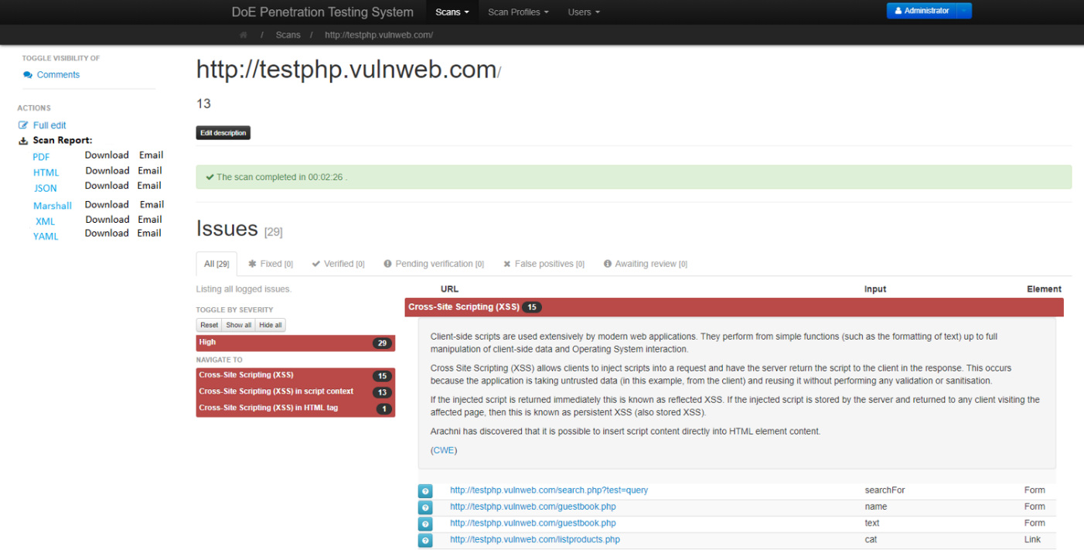
2: PDF Scan Report Format
The PDF Scan Report Format should follow the structure of HTML Scan Report Format. Please refer to HTML Scan Report Format to see how the content should be organized. Before you implement the PDF format, please discuss the template format with me first.

Overview
Title | Send Scan Report (PDF Format) to Recipient
Description | This use case describes how to send Scan Report (PDF format) through email.
Actors and Interfaces | Regular User/Administrator; Show Scan page¹
Pre-Conditions | The scan is completed.
Basic Flow
1: The use case begins with Regular User/Administrator clicks “Email” button.
2. The system displays a pop-up window² that prompts for receipt Email address.
3. The Regular User/Administrator enters an Email address.
4. The Regular User/Administrator clicks “Send Email” button.
5. The system displays a pop-up windown³ “Scan Report Email Sent”.
6. The Regular User/Administrator clicks “Close” button to close pop-up window.
7. The user case ends successfully.

Alternative Flows
None
Post-Condition
1. Successful Completion
The recipient received Scan Report (PDF format).
(Please note: this use case uses PDF format as an example. This test case will be applied to other scan report format, such as HTML, JSON, Marshall, XML, and YAML. The Scan Report in all different formats should be able to be sent through Email.)
1: Show Scan page

2. Pop-up window (Email prompt window)
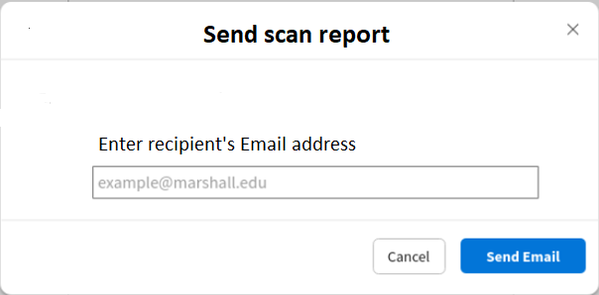

3. Pop-up window (Email sent)
